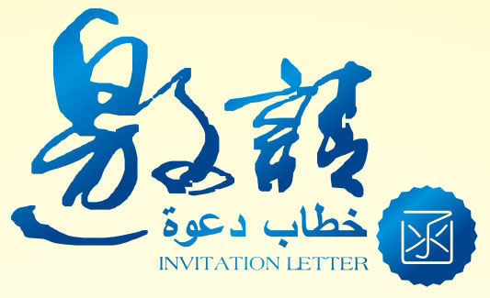

2012中国（宁夏）国际投资贸易洽谈会
暨第三届中国·阿拉伯国家经贸论坛
2012 China（Ningxia）International Investment and Trade Fair
& the 3rd China-Arab States Economics and Trade Forum

Sponsored by ：Ministry of Commerce of the People's Republic of China
China Council for the Promotion of International Trade
People’s Government of Ningxia Hui Autonomous Region
Hosted by： People’s Government of Ningxia Hui Autonomous Region

Sept. 13- 17, 2012
Yinchuan, Ningxia, China

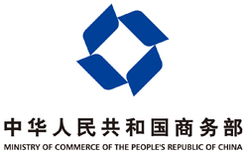
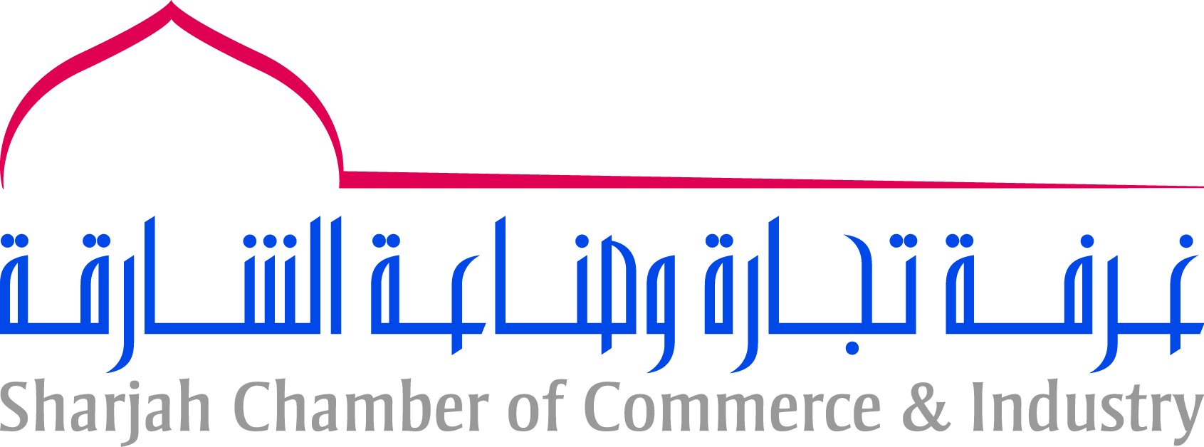
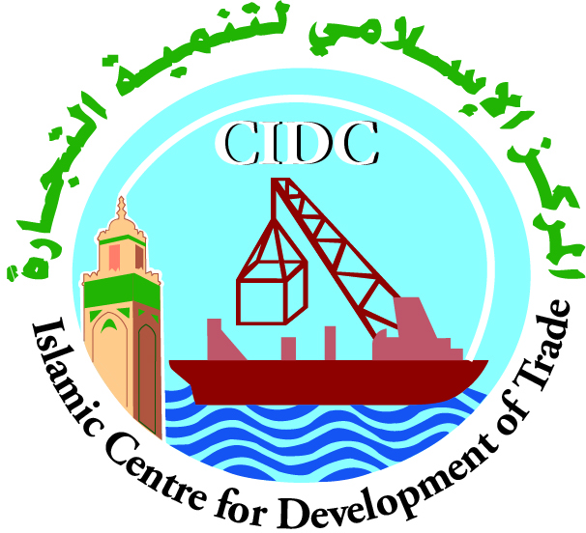
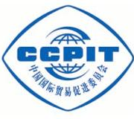

2012 China（Ningxia）International Investment and Trade Fair & the 3rd China-Arab States Economic and Trade Forum (hereinafter referred to as Fair & Forum) is a grand international gathering for economic and trade exchange at national level, which is jointly sponsored by the Ministry of Commerce of China, China Council for the Promotion of International Trade and the People’s Government of Ningxia Hui Autonomous Region. Hosted by the People’s Government Ningxia, the fair and forum will be staged in Yinchuan ,Ningxia in September 12—16 2012,with the theme of “Friendship·Cooperation·Development”. With Arab states and Islamic countries as the major participating group, the Fair & Forum is also open to other countries and regions in the world.
2012 China（Ningxia）International Investment and Trade Fair & the 3rd China-Arab States Economic and Trade Forum extends warm welcome the following professional personals.
▲purchasers, manufacturers, agents, wholesalers, retailers, importers and exporters
▲investors, financing businessmen, project owners, trade agents, financing service organizations
▲experts, scholars and scientific institutions
Professional Exhibitions for Infinite Business Opportunities
▲China International Halal Food and Muslim Commodities Exhibition
Halal lamb and beef products, dairy products, beverage, snacks, seasoning as well as characteristic agricultural products, ethnic costume, cashmere products, arts and crafts, cultural items, detergent for Muslim and other articles for daily use
▲China-Arab States Energy and Chemical Products Exhibition
Petroleum and Petrochemicals：oil-gas exploration, exploitation and manufacturing equipments，oil recovery techniques and the relevant equipments, techniques and equipments for oil & gas pipeline establishment, refining technologies and techniques, equipments for package, transporting, loading and uploading of petroleum and petrochemical products
Coal and Energy：coal mining equipments, coal washing and dressing equipments, extracting and using coal bed gas, applied technology for coal industry; display of new techniques, advanced equipments and latest products as power generation by coal bed gas and coke gas
New Energy：PV production equipments, PV-applied products, applied technologies and products integrating light, power and building, wind power generator and supporting equipments and technologies, biomass power generation, clean use of geothermal energy and coal, display products with application of heat radiation and new light sources
▲Specialties display areas
Special food: fresh and dried fruits, recreation food, special drink, condiment, agricultural and side-line products and etc.
Handicraft products: carving and sculpture, embroider and paper-cut, handicraft, gift, furnishings and accessories, small pieces of furniture and etc.
Consumer goods: cleaning tools and products, bath products, kitchen supplies, small household electronic appliances, textile and clothing, household products and etc.
▲International exhibition areas
Products from Islamic Countries: halal food，commodities，clothing & accessories，arts and crafts and etc.
Comprehensive exhibition of culture and tourism: integrated display of the participating countries’ economic, culture, technology, tourism and etc.
Concurrent events of 2012 China（Ningxia）International Investment and Trade Fair & the 3rd China-Arab States Economic and Trade Forum
▲The 3rd China-Arab States Economic and Trade Forum
▲China-Arab States Cultural and Art Festival
▲Other Activities
The 2nd Summit Meeting of China (Yinchuan) International Muslim Entrepreneurs
The 8th Annual Conference of China-Malaysia Business Council & China-Malaysia Business Forum
The 5th China (Ningxia) Hui Merchants Fair
The 7th Ningxia-Taiwan Economic and Trade Cooperation Fair
The 4th Halal Food and Muslim Commodities Enterprises Competition
2012 Seminar on Chinese and Arabia Chambers of Commerce

Organizer：Organizing Committee Office of China（Ningxia）International Investment and Trade Fair & China-Arab States Economic and Trade Forum
Contact Organization： Expo Bureau of Ningxia Hui Autonomous Region
Address： Xinye mansion 10th floor YinJiaqu Road Jinfeng Area Yinchuan city Ningxia

